PRO1:
My procrastination behavior

Set a timer to 6 minutes and write down your thoughts that come up regarding the following questions. In case you get stuck, doodle on your paper until new thoughts are coming.

Which activities am I putting off/avoiding?
What do I do instead?

In which situations do I feel energetic and resolved in contrast?

PRO2
Questionnaire on reasons for academic procrastination
adapted from Patrzek et al. (2014)

In the following, you will be see a list of potential reasons for your procrastination behavior regarding your studies/university related tasks. Please indicate which of the reasons apply to your procrastination behavior.

Lack of time management
- because I overestimate the time available when planning for a task.
- because I underestimate the required time when planning for a task.
- because I set unrealistic goals when planning for a task.
Lack of self-motivation
- because I cannot motivate myself to start working on my tasks.
- because I cannot motivate myself to finish my tasks.
- because I cannot motivate myself to continue working on my tasks.
Lack of perseverance
- because I find it difficult to persevere with my tasks.
- because it is difficult for me to stay on task for a longer period of time.
- because I have a hard time focusing on my assignments.
Lack of study skills
- because I do not know how to start working on my tasks/assignments.
- because I do not know how to work on my assignments when I have difficulties with the content.
- because I do not know how to select important content when working on my assignments.
Lack of self-confidence
- because I have a poor opinion of myself.
- because I have little self-confidence.
- because I question my abilities.

Questionnaire on reasons for academic procrastination
adaptiert nach Patrzek et al. (2014)

Perfectionism
- because I want to do particularly well in my studies.
- because I want to have particularly good grades.
- because I want to impress others with a particularly good performance in my studies.
Fear
- because I am afraid of embarrassing myself in front of others.
- because I am afraid of not being able to cope with my tasks in my studies.
- because I am afraid of doing a bad job in my studies.
Arousal-Procrastination
- because I can only do my best in my studies when I am under pressure.
- because I can work best under pressure in my studies.
- because I perform better in my studies under pressure.
Uncertain decision regarding my studies
- because I am unsure whether I want to continue my study program.
- because I am unsure whether my decisions in my studies are the right ones.
- because I don't know if the direction of my studies matches my current interests.
Previous success in spite of procrastination
- because my procrastination in the past did not have negative consequences for me.
- because in the past, despite my procrastination, I still got my assignments done on time.
- because I have been successful in the past despite my procrastination.
Aversive Aufgabe
- because I find my tasks pointless.
- because I find my tasks boring.
- because I don’t enjoy my tasks.
Elaborate task
- because my tasks are extensive.
- because my tasks are strenuous.
- because my tasks are time-consuming.
From:
Patrzek, J., Grunschel, C., König, N., & Fries, S. (2014). Fragebogen zu Gründen akademischer Prokrastination. Diagnostica.

PRO3:
Observation task for Video I

On the next two pages, please protocol the time spent working on your project during the next five workdays.
This task will take you about 3-5 minutes per day. This worksheet assumes 5 workdays per week.

Work protocol
Write down the actual time for each day that you spend working on your project. Only include the time that you spent actually working productively.
Day
Time spent working (in min)

Observation task for Video I

Procrastination Episodes
In case they occurred, also protocol your procrastination episodes, one per day on up to five days.
Time | Postponed Activity | Activity performed instead | Feelings before procrastinating | Feelings during procrastinating

PRO4:
Evaluating the observation task

Set a timer to 5 minutes and write down thoughts that come up regarding the following questions. In case you get stuck, doodle on your paper until new thoughts are coming.

Which attitude do I have towards studying or more specifically towards the project that I am currently working on?
Which thoughts and feelings arise when thinking about this project?

PRO5:
Make your choice: Which picture resonates with you the most?

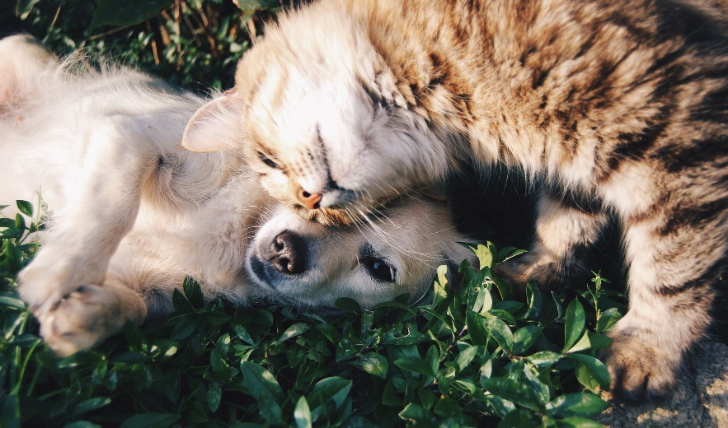


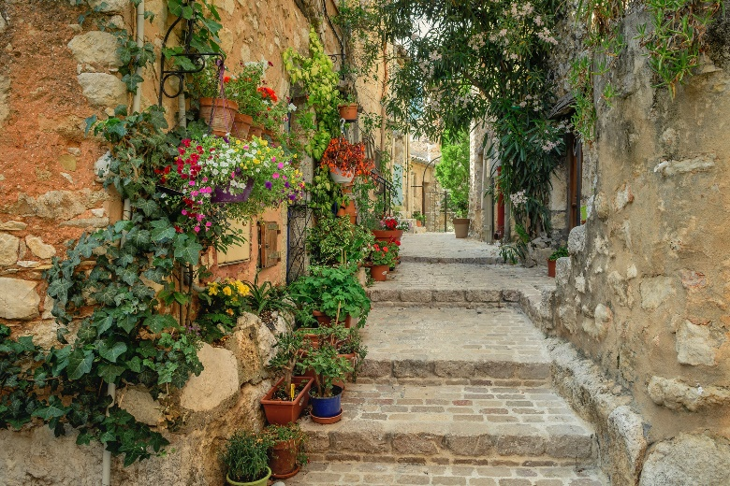

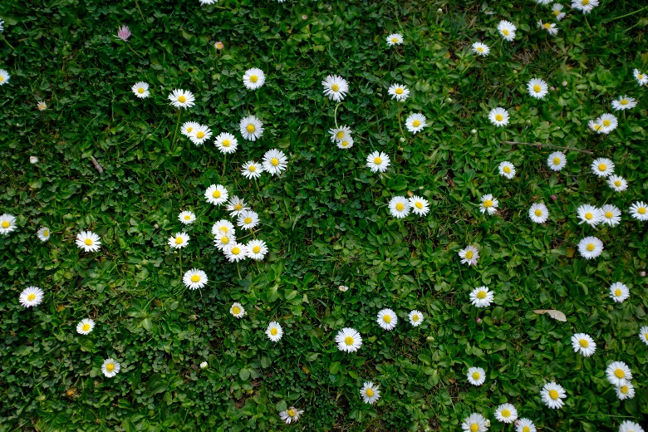

Bildauswahl: Welches Bild spricht mich am meisten an?

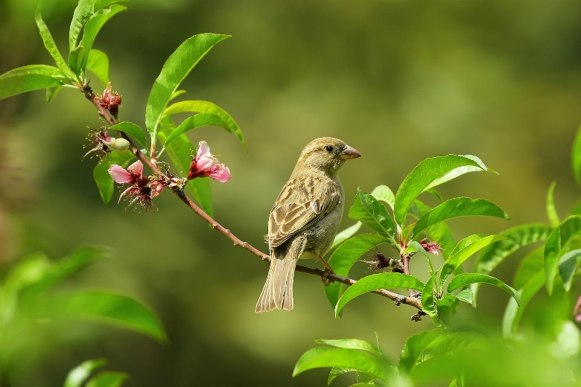


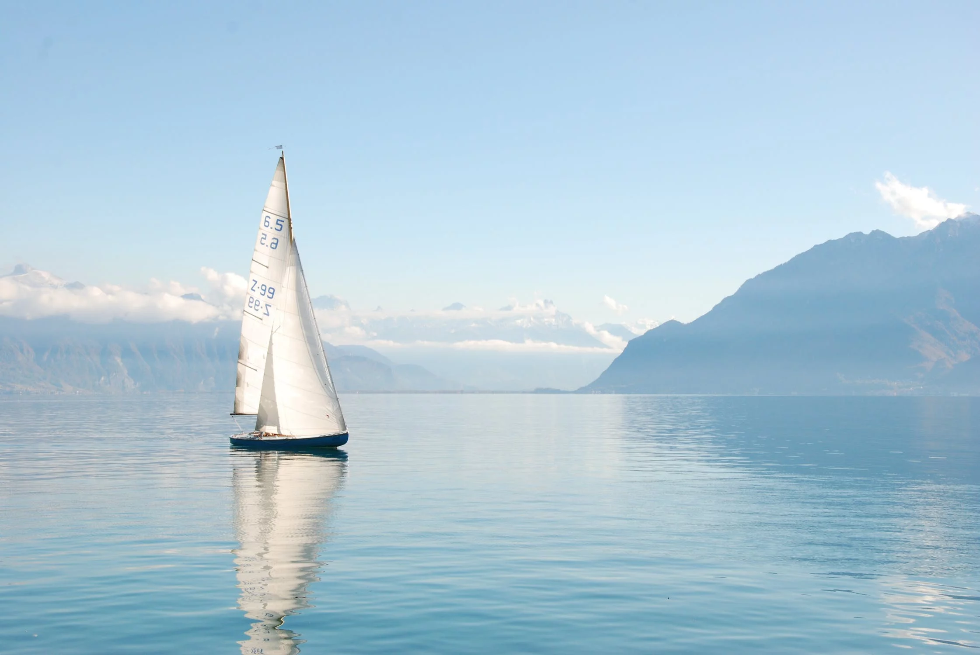

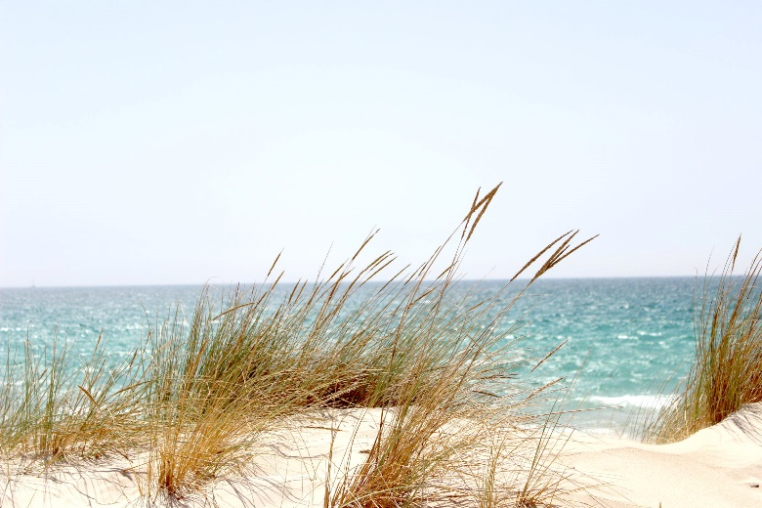
Picture Weblinks

Fruit and vegetables:
https://www.pexels.com/de-de/foto/essen-frisch-frucht-gemuse-1508666/
Girl taking a picture:
https://www.pexels.com/de-de/foto/alt-architektur-bekannt-beruhmt-2087391/
Alley with flowers:
https://www.pexels.com/de-de/foto/alte-straaye-architektur-bla-hende-plfanzen-burgersteig-2849223/
Cat and dog:
https://www.pexels.com/de-de/foto/chillen-draussen-entspannen-freunde-46024/
Snowy mountains:
https://www.pexels.com/de-de/foto/abenteuer-abhang-alpen-alpin-714258/
Daisies:
https://www.pexels.com/de-de/foto/natur-blumen-sommer-garten-4044065/
Bird on twig:
https://www.pexels.com/de-de/foto/vogel-blumen-tier-pflanze-70069/
Lakeview:
https://www.pexels.com/de-de/foto/aussicht-baume-berge-dock-747964/
Beach with reeds:
https://www.pexels.com/de-de/foto/dammerung-draussen-dune-dunen-662994/
Forest path:
https://www.pexels.com/de-de/foto/baume-beratung-blatter-draussen-615348/
Eagle flying:
https://www.pexels.com/de-de/foto/adler-berge-dammerung-dessert-755385/
Sailboat:
https://www.pexels.com/de-de/foto/ausruhen-berge-boot-draussen-273886/

PRO6:
Positive Associations with your picture

Open the web link with your picture or take a picture of it with your phone. Place it so that it is easily visible. Set a timer to 3 minutes and write down all positive thoughts and associations that come up when looking at then picture.

Which positive associations do I have towards when looking at the picture?

PRO7:
Creating a goal theme
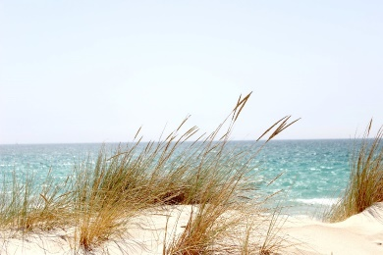

„I will study without fear“

Goal theme guidelines:
- First person
- Present tense
- "I allow/enjoy/enjoy" instead of "I want/can/will".
- Avoid negatives, "un-", "-less".
- Keep it short and sweet

„I am going my way with strength.“

Formulate your goal themed based on your insights from the observation task and on the positive associations from your picture. Say it out loud to check whether it feels right and adapt it if necessary.

PRO8:
Anchor your goal theme
Come up with several reminders that help you to mentally activate your goal theme as often as possible in your everyday life.

Stationary reminders….
(Reminder stays in the same place, e.g. a picture on the wall, desktop home screen…)

Mobile reminders….
(You can take the reminder with you, e.g. Symbol on your key chain, note in your wallet, background on your phone, …)

PRO9:
Rituals for getting started

Write down your ideas for rituals you could try to help you getting started with work. Pick at least one to try out next week.

PRO10:
Observation task for video II

On the next two pages, please protocol the time spent working on your project during the next five workdays.
This task will take you about 3-5 minutes per day. This worksheet assumes 5 workdays per week.

Work protocol
Write down the actual time for each day that you spend working on your project. Only include the time that you spent actually working productively.
Day
Time spent working (in min)

Task protocol
Please document the individual tasks of your project that you have completed. Before working on the task, estimate how long you think it might take. After completing the task, write down the actual duration of the task.

Task | Estimated Duration | Actual Duration

PRO11:
Evaluating the observation task

Look at the records of your work hours from the last two weeks as well as the record of the time estimates of individual tasks from last week. Based on this, answer the following questions.

- How long can I realistically work in a focused manner per day?
- On which days and at which times of the day can I work better or with more ease, and on which days or at which is it more difficult for me?
- How realistic was my estimate of how long the individual tasks would take?
- Which tasks did I underestimate, which ones did I overestimate?
- At what time of day do I prefer to do what kind of tasks?

PRO12:
Plan for next week

Plan your work for the next 7 days here. Take into account breaks, two days off and other commitments. Define the beginning and end of work, and schedule two work units per day.

PRO13:
Disruptions during work

- Please write down all disruptions that can occur while you work/study.
- Then, mark internal disruptions (hunger, urge to look at phone,…) in one color and external disturbances (noise, phone call, ...) in another color.

PRO14:
If-then plans

From the potential disruptions you have just collected, select 5 and formulate 1-2 if-then plans for each of them. Write them down in complete sentences.

Disruption | If X occurs, I will do Y…

